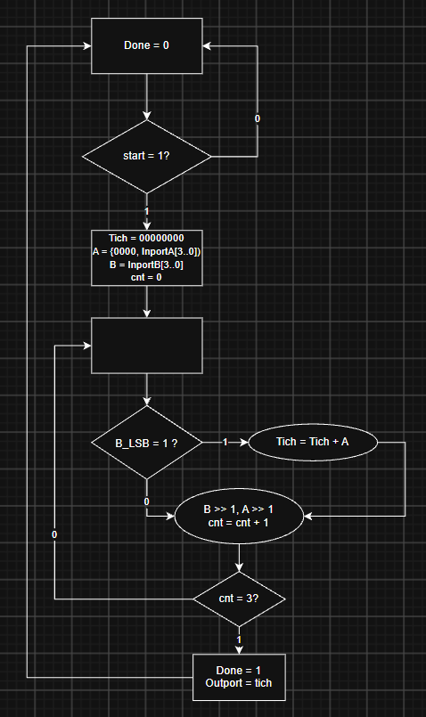

Present state |  | Next state |  | Datapath actions
 | Q1Q0 | condition | state | condition | operations
S0 | 00 | Start = 0 , S0  Start = 1 , S1 |  |  | Done = 0
S1 | 01 |  | S2 |  | Tich = 00000000  A = {0000, InportA[3..0]}  B = InportB[3..0]  Cnt = 0
S2 | 10 | Cnt = 3 true , S3  Cnt = 3 false , S2 |  | B_LSB = 1 , Tich = Tich + A  - , B >> 1  A << 1  cnt = cnt + 1
S3 | 11 |  | S0 |  | Done = 1  Outport = Tich
Q1_next = Q1 xor Q0
Q0_next = Q1.Q0’.(cnt = 3) + Q1’Q0’.start

Tín hiệu | Phép gán tương ứng
LdA | A = {0000, InportA}
ShA | A << 1
LdB | B = InportB
ShB | B >> 1
ClrT | Tich = 0
LdT | Tich = Tich + A
ClrC | cnt = 0
EnC | cnt = cnt + 1
Done | Done = 1

Trạng thái | Q1Q0 | LdA | ShA | LdB | ShB | ClrT | LdT | ClrC | EnC | Done
S0 | 00 | 0 | 0 | 0 | 0 | 0 | 0 | 0 | 0 | 0
S1 | 01 | 1 | 0 | 1 | 0 | 1 | 0 | 1 | 0 | 0
S2 | 10 | 0 | 1 | 0 | 1 | 0 | B0 | 0 | 1 | 0
S3 | 11 | 0 | 0 | 0 | 0 | 0 | 0 | 0 | 0 | 1

Tín hiệu | Thay cho | Công thức
Init = S1 | LdA, LdB, ClrT, ClrC | Q1'·Q0
Run = S2 | ShA, ShB, EnC | Q1·Q0'
LdT = S2·B0 | Tich = Tich + A | Run·B0
Done = S3 | Done = 1 | Q1·Q0

Register A 8 bit: load, dịch trái, giữ nguyên
Register B 4 bit: load, dịch phải, giữ nguyên
Register T 8 bit: xóa, nạp tổng, giữ nguyên

